Abstract— Identification of initial sedimentary redox conditions by color in peletic rocks can be potentially misleading particularly in metamorphosed sediments Conventionally, black indicates anoxic conditions; green: slightly anoxic, and red: oxic. Mineral stability fields of common Fe and Mn sedimentary minerals at higher temperatures and pH other than at initial depositonal conditions, as depicted in Eh-Ph diagrams for 0, 25, 100, and 200 degrees Celsius, shows that not all black rocks are anoxic nor red rocks oxic. We recommend that estimations of redox conditions should be based on further mineralogical, chemical, metamorphic grade and/or paleontological evidence and color used only as a descriptor of the color of the rock.
Paradoxes and perceptions in color identification of paleo-redox conditions in peletic rocks from diagenic to metamorphic grade
Pat Wilde and Mary S. Quinby-Hunt

Keywords—Color, Eh-pH, Fe, Mn, redox.

INTRODUCTION
Color of sedimentary rocks[1] have been used for years as indicators of redox conditions primarily with red color (oxidized Fe) for oxic conditions and black/brown for reduced conditions for arkoses and black shales. Potter [1] has shown that color in mudrock is influenced almost exclusively by two parameters, the ratio of Fe3+ to Fe2+ and the percent organic carbon in the rock. In the absence of organic carbon, mudrock color varies from red to greenish gray as Fe3+ is progressively reduced to Fe2+. The addition of increasingly greater amounts of organic carbon darkens the mudrock from gray to black. These two parameters are not independent because the presence of any appreciable organic carbon in the sediment virtually assures that all interstitial oxygen will be consumed, leaving undecomposed organic matter that reduces Fe3+ to Fe2+ [2].
With modern optical equipment, color may be objectively analyzed [refs] and is used extensively, for example, for the cores of the Deep-Sea Drilling project. Although the redox interpretation may be valid for unmetamorphosed sediments as in recent sediment cores, but thermodynamically may not the case for meta-sediments now seen as rocks subjected to higher than normal temperatures. Here, the color may be indicative of minerals now metastable observed at now lower field conditions. Wilde, Quinby-Hunt, and Guidotti [3] outlined some of the paradoxes in the Eh-Ph diagrams of the Fe system using increasing temperature as a proxy for metamorphic rank. Sadly we never pursued this further into other systems and into a more formal paper due to the passing of Prof. Guidotti who provided the metamorphic insights. The following is our attempt to continue this discussion using Mn and Fe Eh-pH diagrams [3],[4] and Guidotti’s field work [5].
Background
There is a long held perception that in lieu of other information, the color of many peletic rocks in the field gives an indication of relative redox conditions. Briefly stated that red rocks indicated ‘oxic’; green: ‘slightly reduced’; and black: highly reduced. Even in classic anoxic ‘black’ shales such as those of the Ordovician of New York [6], the field descriptions show variations in color including green and red which seemingly belie anoxic conditions. To examine these potential paradoxes we follow Baas-Becking and others[7] (1960), Krumbein and Garrels [8], and Garrels and Christ [9] in the use of Eh-pH diagrams for the interpretation of natural systems. and demonstrate for common and potentially pigmenting Fe and Mn mineral phases that this is not universally true and in many cases very misleading. We use the Fe and Mn composition of the metamorphic Small Falls Formation [5] as an example in honor of Prof. Guidotti’s long association with the metamorphic rocks of Maine.

Iron System

Figure 1 depicts the Eh-Ph diagrams of the mineral stability in the Fe-S-O system for hematite (Fe₂O₃), pyrite (FeS₂₎, pyrrhotite (Fe_{.87}S), magnetite (Fe₃O₄) at temperatures of 0, 25, 100, 200 degrees Celsius. Concentrations were [Fe] = 4e⁻⁴ M Silurian Small Falls [5] and [S] = 2 e⁻³ M [9]. As shown hematite, a strong red pigment, has an appreciable stability range in the anoxic field below an Eh of 0. Accordingly if hematite were introduced into sediments, at these temperatures, they potentially would be colored red even if the interstitial conditions were anoxic. We stress the hematite does not have to form in anoxic conditions, just that it would be stable and survive early diagenesis. However, oxidants such as nitrate and nitrate, could produce authogenic hematite below Eh 0, if present in sufficient quantities [10]. Nitrate and nitrite are likely to be common in the upper pycnocline in the pre Devonian world, with lower atmospheric oxygen before the development of land plants [11],[12]. In the modern ocean nitrate, and nitrite are found in limited but in sufficient amounts in the oxygen minimum zones [13]. Additionally, Konhauser and others [14] suggested that the banded iron formations may have been produced by phototrophic bacteria in the low oxygen world of the Precambrian. Introduction of hematite into anoxic waters, for example, as in lateritic sediments, would not be an uncommon occurrence in tropical areas, particularly in near shore areas where organic productivity would deplete oxygen in the overlying water column. Darwin [15 noted the occurrence red dust on the Cape Verde Islands extending to South American apparently blowing across the Atlantic during the Harmartan season in the Sahara. Thus red pigment could be introduced into the hemi-pelagic component of marine sediments. In summary, if present, hematite may color sediment red in the following anoxic conditions.
Eh value at lower hematite Boundary for pH 7
0 C with FeS₂………….. -0.1
25 C with FeS₂…………. -0.2
100 C with FeS₂ ………… -0.3 and Fe₃O₄
200 C with Fe3O4……….. -0.4
For more acidic conditions than pH 7, hematite is less stable in anoxic conditions.
Minimum pH for hematite stability at redox boundary (Eh =0)
0 C with FeS₂………….. 5.5
25 C with FeS₂…………. 4.8
100 C with FeS₂ ………… 3.6
200 C with Fe₃O₄……….. 2.8
For more alkaline conditions (seawater pH is essentially 8), hematite is more stable in more anoxic conditions.
Minimum Eh (maximum anoxicity) for hematite stability within stability field of water
0 C with Fe₃O₄………. -0.4 at pH 14
25 C with Fe₃O₄………. -0.6 at pH 14
100 C with Fe₃O₄ ……… -0.82 at pH 14
200 C with Fe₃O₄………. -1.3 at pH 14
Within the stability field of water and these typical Fe concentrations, anoxic sediments could be red (hematite), green (fine grained pyrite?), or black (magnetite).

Manganese System
Figure 2 shows the Eh-Ph diagrams for the mineral stability in the Mn-S-O system for, pyrolusite (MnO₂), manganite (Mn₂O₃), hausmanite (Mn3O4), alabandite (MnS), again at 0, 25, 100, 200 degrees C and using the same concentrations of the Small Falls Formation[5] and Silurian sea water [9]. In all cases over natural Eh-Ph conditions, these minerals would color a sediment black. Thus, the black color of any sediment with significant amounts of Mn minerals can not indicate uniquely redox conditions.

Redox Indicators
If color is an ambiguous redox indicator, what can one use?? Jones and Manning [16] have proposed eight redox indicies: DOP (degree of pyritisation), C/S, U/Th, authogenic U, V/Cr, Ni/Co, Ni/V, (Cu+Mo)/Zn, based on Jurassic rocks. Berner and Raiswell [17] suggested significant organic carbon content would be a sufficient anoxic indicator. Certainly graphite would be an anoxic indicator for metamorphic rocks such as observed in the Small Falls [5]. Quinby-Hunt and Wilde [18],[19]proposed four chemical zones for ‘black rocks’ using ranges of Fe, Mn, and V. Wilde and others [20] used the Ce anomaly to identify relative redox conditions, although without assigning Eh, pE, or oxygen values. Basically, these are still qualitative indicators, with no confirmed relation of the various ratios to the ‘Holy Grail’ of actual Eh or pH values. Another perplexing problem is the confusion of whether the assigned redox conditions refer to the sediment or the overlying waters. In general, low porosity-low permeability sediments such as muds would be anoxic (below Eh = 0) at or just below the sediment surface regardless of the redox potential of the overlying waters.

Acknowledgments
R. A. Berner and M. R. VanBaalen for their comments and insights on the concepts discussed in this paper. Eh-pH diagrams were constructed using the Outokumpu ‘HSC Chemistry for Window’ program Version 3 (© 1974-97 Outokumpu Research Oy).

References

[1] Potter, P. E. (1981) “Classification of shales: one for every point of view”, in Annual Field Conference of the Geological Society of Kentucky, (Pryor, W. A., Maynard, J. B., Potter, P. E. Kepferle, R. C. and Kefer, J., vol 1981, pp 12-17, 1981.
[2] Berner, R. A., “Sedimentary pyrite formation”. Am. Jour. Sci.. 268, 1-23, 1968.
[3] Wilde, P., M. S. Quinby-Hunt,. and C. V. Guidotti, C. V., “Paradoxes in the phase relationships considering redox pathways from anoxic muds to variably oxic metapeletic schists” (ABST): Geol. Soc. America 1997 Ann. Mtg. vol. 29, no. 6, A450, 1997
[4] Schmitt, H. H. (1962) Equilibrium diagrams for minerals at low temperature and pressure. Geological Club of Harvard, Cambridge, Mass., 199p., 1962.
[5] Garrels, R. and C. L. Christ, “Solutions, Minerals and Equilibrium”. Harpers, New York 450p., 1965
[6] Cullers, R. L, B. Bock and C. Guidotti, “Elemental distributions and neodymium isotopic concentrations of Silurian metasediments, western Maine, USA: Redistribution of the rare earth elements”, Geochim Cosmochim Acta, vol. 61, pp. 1847-1861, 1997.
[7] Berry, W. B. N. “Stratigraphy, zonation, and age of Schaghiticoke, Deepkill, and Normanskill shales, eastern New York”. Geol. Soc. America bull., vol. 73, pp. 695-718, 1962
[8] Baas-Becking, L. G. M, I. R. Kaplan and O. Moore, “Limits of the Natural Environment in Terms of pH and Oxidation-Reduction Potentials”. Jour. Geol., vol. 68, pp. 243-284, 1960
[9] Krumbein, W. C. and R. M. Garrels “Origin and classification of chemical sediments in terms of Eh and oxidation-reduction potentials.” Jour. Geol.. vol. 60, pp.1-33, 1952.
[10] Berner, R. A, “A model for Calcium, Magnesium and Sulfate in Seawater over Phanerozoic time”. Am. Jour. Sci., vol 304, pp. 438-453, 2004. 2004
[11] Stumm, W. and Morgan, J. J. (1970) Aquatic Chemistry and Introduction emphasizing Chemical Equilibria in Natural Waters. Wiley-Interscience, New York, 583p
[12] Wilde, P. (1987) “Model of progressive ventilation of the Late Precambrian-Early Paleozoic ocean”, Am.Jour. Sci., vol. 287, pp. 442-459, 1987
[13] Canfield, D. E. “A new model for Proterzoic ocean chemistry”. Nature, vol. 396, pp. 450-453, 1998.
[14] Anderson, J. J., A. Okubo, A. S. Robbins and F. A. Richards, “A model for nitrite and nitrate distributions in oceanic oxygen minimum zones”. Deep-Sea Res., vol 29, pp. 1113-1140, 1982 .
[15] Konhauser, K. O., T. Hamade, R. Raiswell, R. C. Morris, F. G. Feris, F. G, G. Southam and D. E. Canfield, “Could bacteria have formed the Precambrian banded iron formations?” Geology, vol. 30, pp.1079 -1082,
[16] Darwin, C. R. 1860. “Journal of researches into the natural history and geology of the countries visited during the voyage of H.M.S. Beagle round the world, under the command of Capt. Fitz Roy R.N”, London, John Murray. 552 p (1890 edition), 1860.
[17] Jones, B. and D. A. C. Manning. (1994), “Comparison of geochemical indices used for the interpretation of paleoredox conditions in ancient mudstones”. Chem. Geol., vol. 111, pp. 111-129, 1994.
[18] Berner, R. A. and R. Raiswell, “Burial of organic carbon and pyrite sulfur in sediments over Phanerozoic time”. Geochim.et Cosmochim. Acta, vol.. 47, pp.855-862, 1983.
[19] Quinby-Hunt, M. S. and P. Wilde,. “Thermodynamic zonation in the black shale facies based on iron-manganese-vanadium content”, Chem. Geol.. vol. 113, pp. 297-317 1994.
[20] Quinby-Hunt, M. S. and P. Wilde, P. (1996) “Chemical depositional environments of calcic black shales”. Econ. Geol., vol. 91, pp. 4-13., 1996.
[21] Wilde, P., M. S. Quinby-Hunt, M. S. and B.-D. Erdtmann, B.-D.,“The whole-rock cerium anomaly: a potential indicator of eustatic sea-level changes in shales of the anoxic facies”, Sed. Geol.., vol. 101, pp. 43-53, 1996

Figure 1 Eh-ph diagrams for Small Falls concentration Fe (4e⁻⁴ M) - Silurian sea water S (2e⁻³ M).
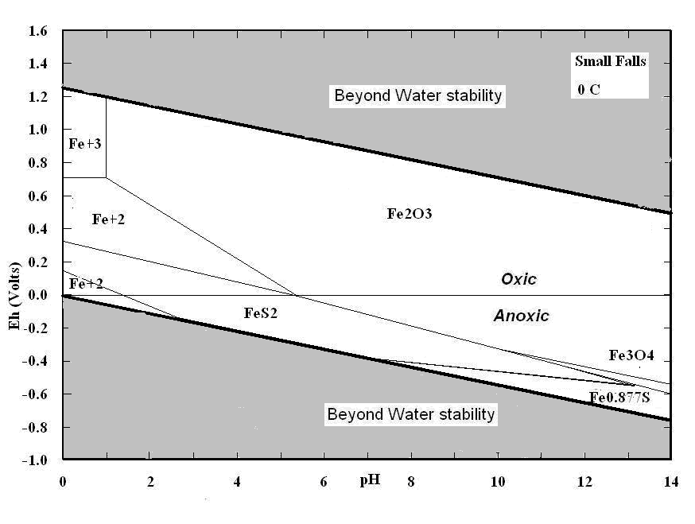
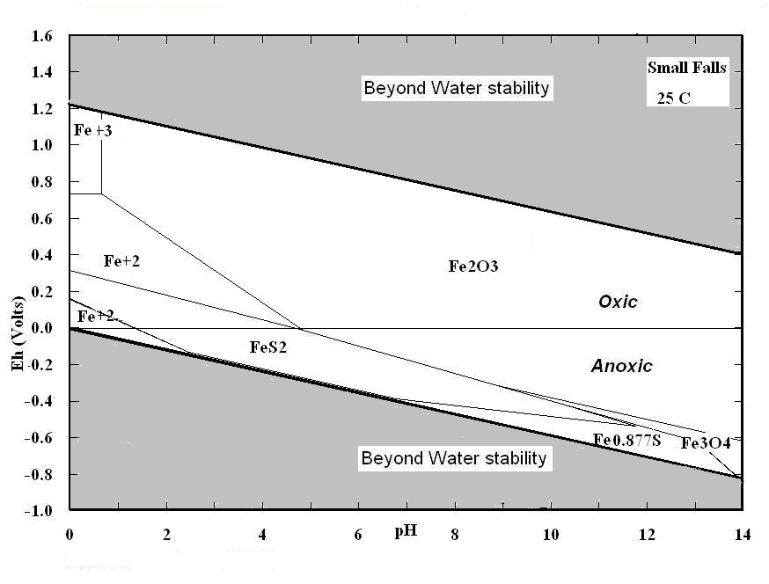
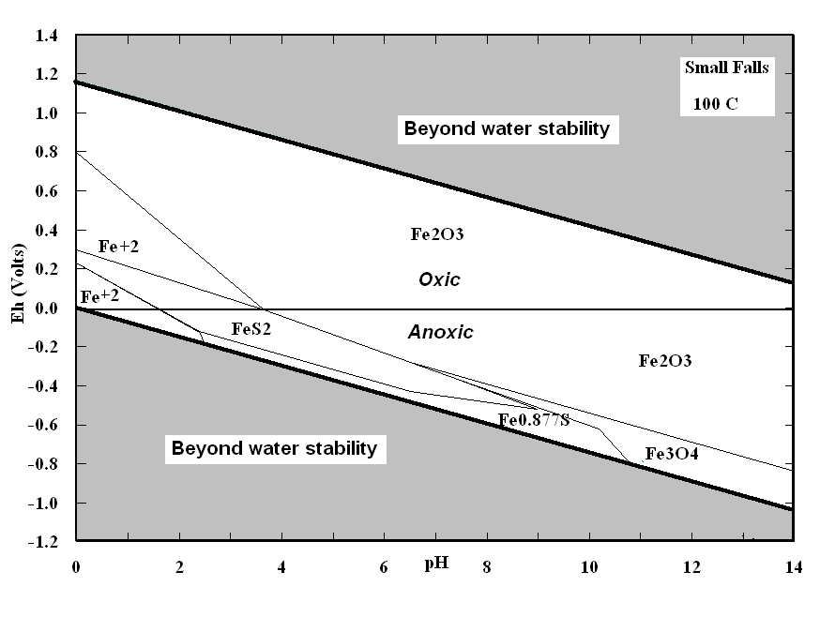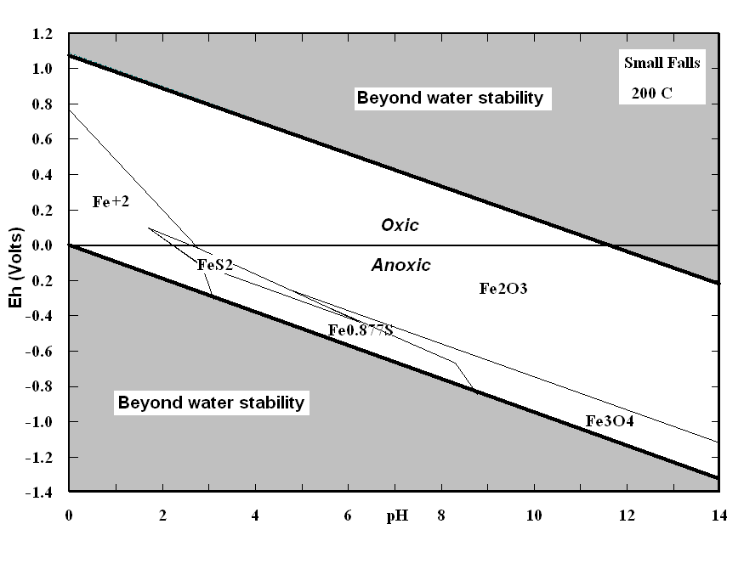
Figure 2: Eh-pH diagrams for Small Falls concentration Mn (8e⁻⁶ M) - Silurian sea water S (2e⁻³ M).

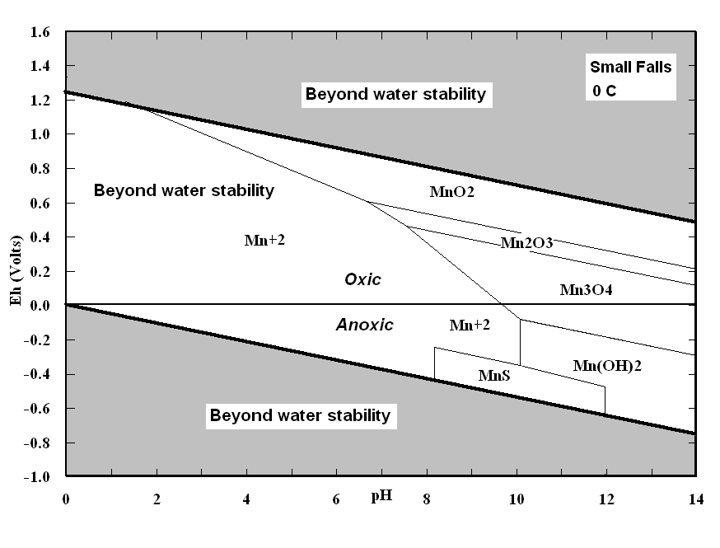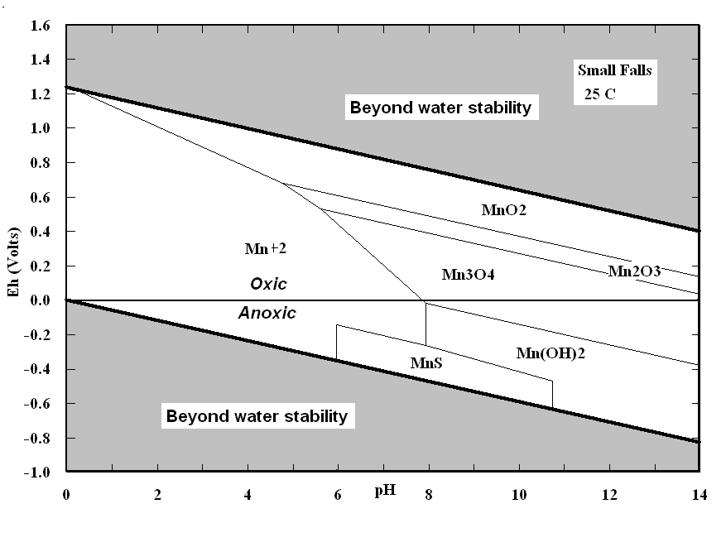
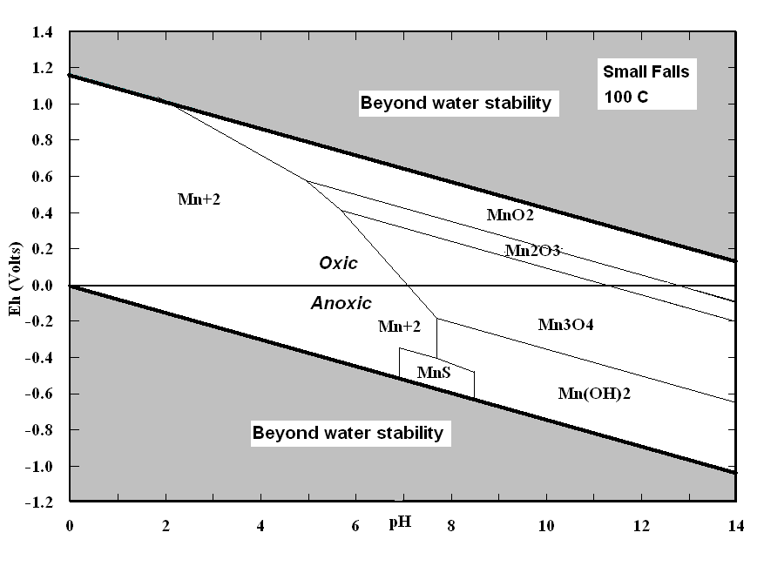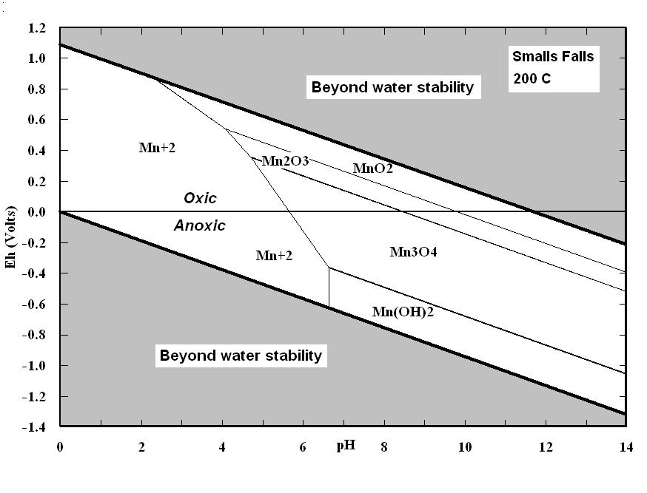
.

 Manuscript received March 4, 2011 This work was supported by the Pangloss Foundation General Research Funds Pat Wilde is with the Pangloss Foundation, Berkeley, CA 94709 USA, retired from Univeristy of California, Berkeley and the Office of Naval Research . phone:510-841-4721, e-mail: pat.wilde.td.57@aya.yale.edu Mary S. Quinby-Hunt is with the Pangloss Foundation, Berkeley, CA 94709 USA, retired from the Lawrence Berkeley Laboratory. e-mail: mshunt@sbcglobal.net

